Homework 5 - Mahamat Tahir Badr - 242910701130
#include <iostream>
using namespace std;
class BothStack {
private:
int* data;
int size;
int top1, top2;
public:
BothStack(int s = 100) {
size = s;
data = new int [size];
top1 = -1;
top2 = size;
}
~BothStack() {
delete[] data;
}
void Push(int i, int x) {
if (top1 + 1 == top2) {
cout << "Stack Overflow!\n";
return;
}
if (i == 1)
data[++top1] = x;
else if (i == 2)
data[--top2] = x;
else
cout << "Invalid stack index!\n";
}
int Pop(int i) {
if (i == 1) {
if (top1 == -1) {
cout << "Stack1 Underflow!\n";
return -1;
}
return data[top1--];
}
else if (i == 2) {
if (top2 == size) {
cout << "Stack2 Underflow!\n";
return -1;
}
return data[top2++];
}
else {
cout << "Invalid stack index!\n";
return -1;
}
}
void Display() {
cout << "Stack1: ";
for (int i = 0; i <= top1; i++)
cout << data[i] << " ";
cout << "\nStack2: ";
for (int i = size - 1; i >= top2; i--)
cout << data[i] << " ";
cout << endl;
}
};
int main() {
BothStack s(20);
int arr1[] = { 1, 2, 3, 4, 5 };
int arr2[] = { 7, 8, 9, 10, 11 };
for (int x : arr1) s.Push(1, x);
for (int x : arr2) s.Push(2, x);
cout << "All elements in BothStack:\n";
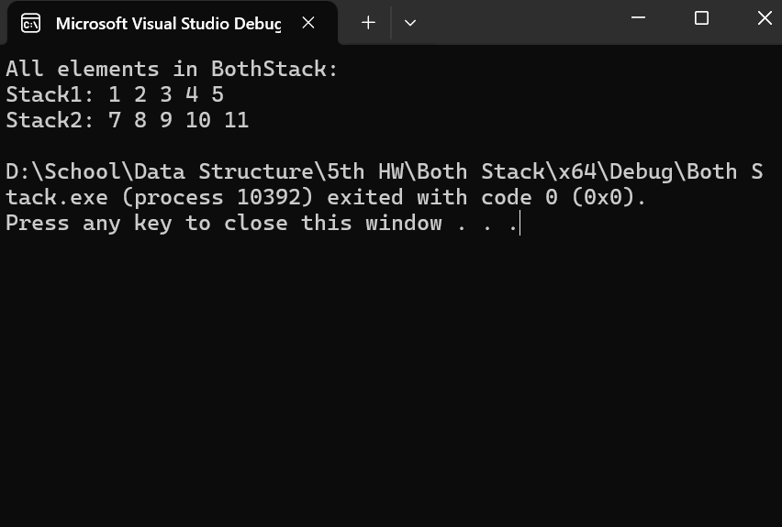
s.Display();
}

